**MID TERM ONE ASSESSMENTS 2024**

**PRIMARY THREE**

**MATHEMATICS**

Time Allowed: **2** Hours **30** Minutes

Name:____________________________________________________________

District:___________________________________________________________

**DO NOT OPEN THIS BOOKLET UNLESS YOU ARE TOLD TO DO SO.**

**Read the following instructions carefully**;

1. This paper consists of two sections.
2. Section **A** has **20** questions (**40** marks)
3. Section **B** has **12** questions (**60** marks)
4. Attempt **ALL** questions in either section. All answers to either section must be written in the spaces provided.
5. All answers must be written with blue or black ball-point pens. Only diagrams and graph work must be done in pencils.
6. Unnecessary alteration of work will lead to loss of marks.
7. Any illegible handwriting may lead to loss of marks.

**FOR EXAMINER’S USE ONLY**

|  |  |  |
| --- | --- | --- |
| SECTION | MARKS | REMARKS |
| A |  |  |
| B |  |  |
| TOTAL |  |  |

**SECTION A**

1. Add 2 3

+ 2 3

2. Write 124 in words.

3. Simplify. 2/ 4 + ¼

4. Given the digits 2 and 9. Write down the two numbers formed.

5. Draw a set of 4 balls.

6. Solve + 3 = 6

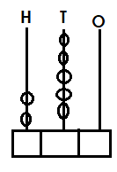7. Complete the abacus below.

8. Share 20 mangoes by 5 boys.

9. Name the figure below.

________________________

10.Write the place value of each digit in 843.

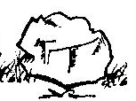11. Given the two stones

 40kg 20kg

Which stone is heavier

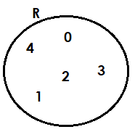12. Given a set

How many members has set R.

_________________________________________________________

13. Fill in the missing value.

3420 = ______ thousand 4 hundreds _____ tens 0 ones

14. Primary three class has 10 boys, 14girls. How many pupils are in P.3?

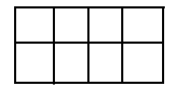15. Shade 5/8 on the figure below.

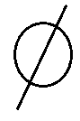16. Name the set symbol below.

________________________

17. How many days make 4 weeks if a week has 7 days?

18. Workout. Sh. 1 5 0 0

Sh. 3 0 0

19. Shade A n B on a Venn diagram below.

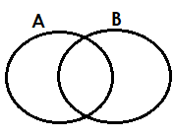

20. Write down the number shown by the tally sticks below.

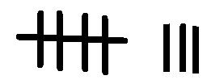

**SECTION B**

21. Martin went to the shop and bought the following items.

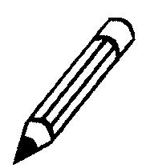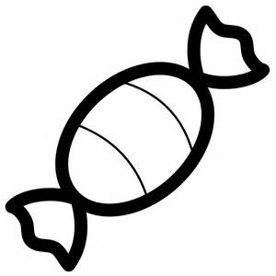book sweet soap pencil

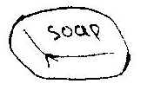

sh. 800 sh. 300 sh. 800 sh. 100

a) Which item costs Sh. 800. 1mks.

___________________________________________________________

b) Find the total cost of a sweet and a pencil. (2mks)

_____________________________________________________________

c) Which two items cost the same amount of money? (2mks)

______________________________________________________________

d) How much money did he pay for a Geisha soap? (1mk)

______________________________________________________________

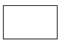22. Fill in the missing numbers in the box

a) - 4 = 5

(2mks)



b) 4 + = 7

(2mks)



c) 6 – 3 =

(1mk)

23. Expand 4382 using values.

(3mks)

b) Write in short 3000 + 400 + 20 + 9 (2mks)

24. Count and match correctly A to B.

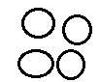 **A B**

two

 eight

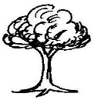 four

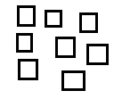

seven



three

25.Draw symbols for the following sets. (3mks)

a)

|  |  |  |
| --- | --- | --- |
| Empty set | Union of sets | Equal sets |
|  |  |  |

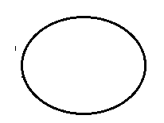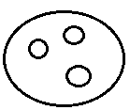b) complete correctly

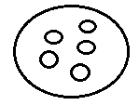

+ =

_________ + 3 = _____________

26. Workout the following.

a) 4 4 4 b) 5 7 8

+ 1 2 3 (2mks) - 2 2 (2mks)

c) 24 ÷ 6 = _________ (1mk)

27. Study the two sets below. Use “more” or “less” to complete correctly.

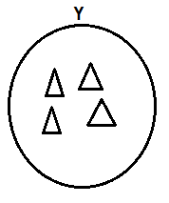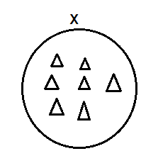

a) Set X has _________ triangles than set Y (1mk)

b) Set Y has _________ triangles than set X (1mk)

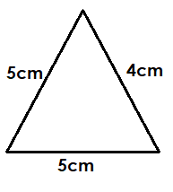28. Find the total distance round the figure below. (2mks)

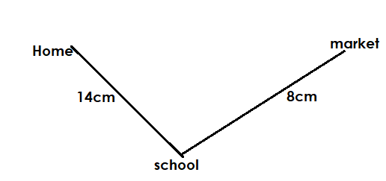b) Workout the total distance from home to market.

(2mks)

29. Fill in the missing numbers. (5 mks)

**______**

**152**

**153**

**154**

**______**

**156**

**157**

**_____**

**159**

**160**

**161**

**______**

**163**

**164**

**______**

30. Given the digits 4,9,6. Write down all the 6 numerals formed from the digits above.

(3mks)

4 9 6

b) Write down the biggest number formed from the above digits.

(1mk)

c) Write down the smallest number formed from the above digits

(1mk)

31. Tell the time on the clock face below.

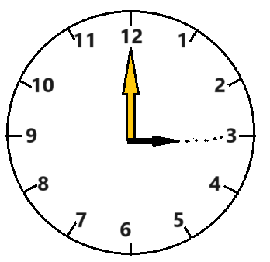2 mks

**___________________**

b). Add this time.

Hours min

4 3 5

+ 2 2 0

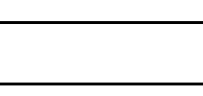

c). Write down the third(3rd ) day of the week (1mk)

______________________________________

32**32. The graph below shows the books read by four pupils.**

**8**

**7**

**6**

**5**

**4**

**3**

**2**

**1**

**0**

***Number of books***

**Dan**

**Ben**

**Joyce**

**Joy**

1. Who read the highest number of books? (1 mk)

____________________________________________________

1. Which boy read one book (2 mks)

_____________________________________________________

1. How many books were read by all the four pupils? (2 mks)